**California State University Long Beach**

**College of Engineering**

**Computer Engineering Computer Science Department**

**Tuesday, November 19, 2019**

**Sixfold Flat File ArchiveDesign Document V3.0**

**Group Members:**

**Michell Kuang (Team Lead) 013421094**

**Joshua McDaniel 014542786**

**Jingyan Du 014436615**

**Peter Park 002948398**

**Jacen Tan 012393782**

**Daniel Gione 016513144**

**Version History**

|  |  |  |  |
| --- | --- | --- | --- |
| **Version** | **Date** | **Author(s)** | **Comments** |
| V1.0 | 11/10/2019 | Jingyan Du | -Original document |
| v2.0 | 11/14/2019 | Jingyan Du | -Fix Diagram Mistakes  -Fix Concept Mistakes |
| V3.0 | 11/19/2019 | Jingyan Du | -Fix Diagram Mistakes  -Fix Concept Mistakes |

# Table of Contents

**Table of Contents** **2**

**Overview** **3**

**The Data Archive Process** **3**

**Timer Trigger** **4**

Possible Error 5

Timer Pass Due 5

**FileCollect** **5**

Possible Error 6

No File IOException 6

Argument Null Exception 6

**Flat File Output** **7**

Possible Error 7

File IOException 7

Copy Fail Exception 8

**File Delete** **8**

# Overview

This Document is made to show design concepts of data archive feature of SixFold Household Manager. To use storage space efficiently, archive systems for logs are necessary. Diagrams for data flowing and error handling will be included to guide the developers.

# The Data Archive Process

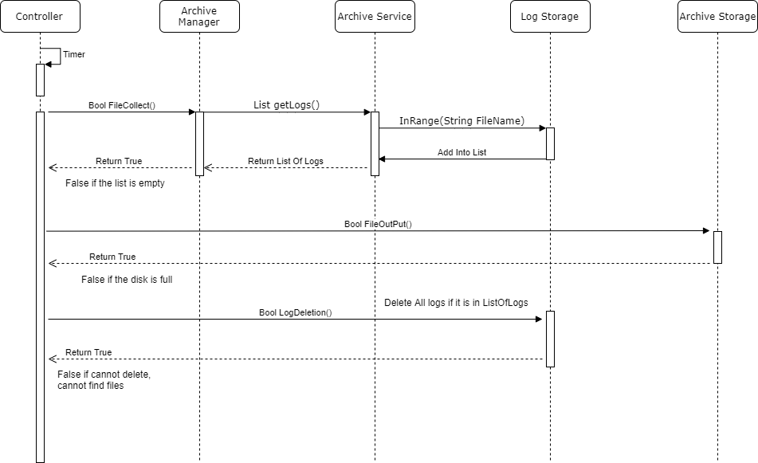

The Archive Service shall always run the timer to check the archive date. Once the time reached 00:00:00:00 UTC at the 1st of a month, the archive shall start, and the timer shall automatically set the datetime for next archive. The CollectFile shall be called, this function shall combine all logging flat files that were at least 30 days old into one flat file. Firstly, this function shall call getLogs function in Service layer to go through the local storage for logs. Any log file that is at least 30 days older shall be added into the list of logs. If the list is returned successfully, FileOutPut function shall be called to output the compressed file. Once the file output is successful, old logs shall be deleted.

# Timer Trigger

The time trigger is always running in the backend to check if the datetime reached the scheduled datetime, only if the current datetime is 00:00:00:00 UTC on the 1st of the month, the timer trigger shall set a new timer for next archive and start the archive. The time trigger should be async.

# Empty List

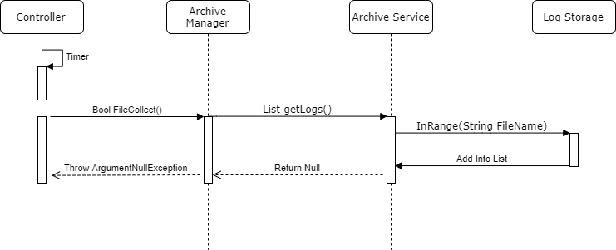

If the Archive Service return an empty list, the archive should not continue since there is no log need to be archived. An ArgumentNullException shall be thrown. And this archive period should be logged as a failure.

# Insufficient Space

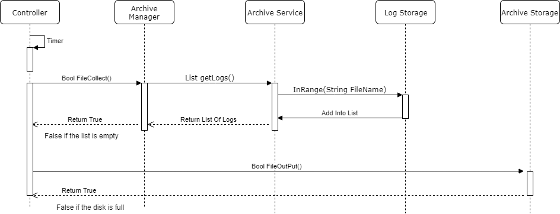

If the ArchiveStorage is full, the output should not continue, the archive process should be stopped and this archive period shall be logged as failure. The output file should be .7z extension.

# FileNotFoundException

The output and the deletion of log files should always using try and catch for FileNotFoundException.

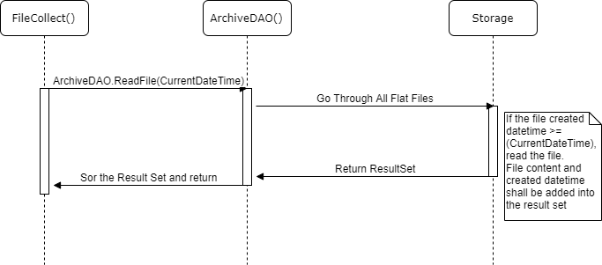

The FileCollect function shall collect all eligible flat files into one result set. The ArchiveDAO shall go check all log flat files in the local storage, only for files created in the eligible range shall be read and their contents could be added into the result set with their created datetime.

Question for archive:

1. Could this be one class?
2. For the flexibility of this program, should we store all settings such as the file path, file name format, date format into one file? Is it safe?
3. Confused about where I should put the timer.
4. Is it recommande for me to put a copy for compressed file first and then check if its size is larger than disk space?

### 

## 

### 